Practice Questions COAL

Q1: Consider the following initialization and code: Assign proper physical addresses to each byte stored in the data segment (Assume DS= ABCD and the starting offset is 2262).

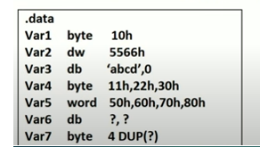

Q.2: Draw a memory map. Show how data is stored (Little Endian) in the data segment memory in bytes. The starting address of the data segment is 04010h.

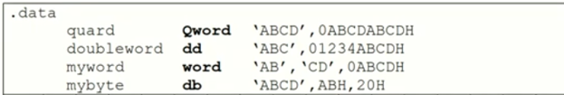

Q.3: (i) Consider the following data declaration and fill in the data segment (DS:SI = 35AD: 1002). (ii) Read .code segment and write the contents of the Registers against each line . In case of error or incorrect value of a particular variable, please mention against each instruction.

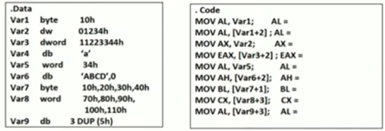
Q.4: (i) Consider the following data declaration and fill in the data segment (DS:SI = A5A2: 1002). (ii) Read .code segment and write the contents of the Registers against each line. In case of error or incorrect value of a particular variable, please mention against each instruction.
.Data
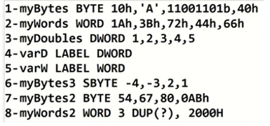

.Code
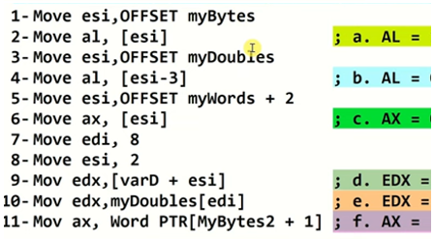

Q.5: Write values of status flag (carray , sign, Auxilary carry, parity , and zero )for theeach of the following instructions:
Instruction | OF | CF | AC | SF | ZF | PF
MOV al, 0DDh
MOV bl, 0C6h
ADD al, bl

MOV ax , 145Dh
MOV bx, 73ABh
SUB ax,bx

MOV ax, 0AB8Fh
MOV bl,0A1h
ADD al,bl

Q.6: Given AX= 0FFFFh , BX = 0001h . Determine the values of status flag (carray , sign, Auxilary carry, parity , and zero )for following cases:
Instruction | OF | CF | AC | SF | ZF | PF
NEG AX
ADD AX, BX
SUB BX,AX
SUB AX, BX
INC AX

Q.7: Find the value of registers in each instruction :
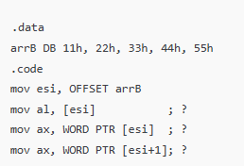
Q.8: Find the value of registers in each instruction :
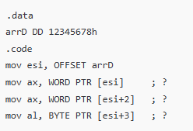
Q.9: Find the value of registers in each instruction :
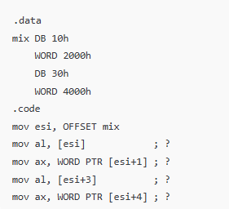
Q.10: Find the value of registers in each instruction :
